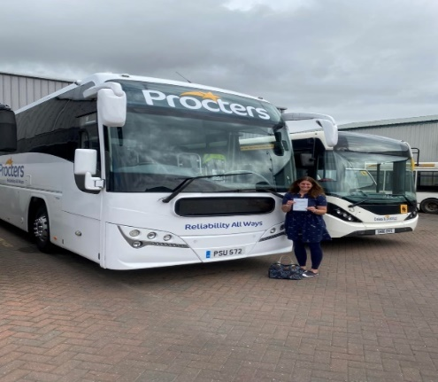

Drivers Job Description.
Working as a coach / bus driver is at times challenging but can be rewarding. Procters is a family run business and growing who own several other businesses working all together as one family.
The role of a coach driver can be varied work which includes the following;
School Contracts (AM &PM)
Private hire work
Military contracts
Tour driving (holidays)
Day trips & excursions
UK & Overseas work
Working away from home staying in hotels
Local bus service work
Rail replacement
Basically, if people need moving from A to B, we do it.

Each driver has a responsibility for keeping the coach clean and presentable when out driving (however we have a cleaning team) you are also responsible to make sure that the coach has enough fuel and AdBlue when its required. Use your driving skill for passenger comfort and safe driving to ensure that the coach arrives at the destination safely and on time.
Any defects are to be reported using our defect reporting system. Vehicle checks are to be carried out at the start of each day and throughout your shift
Seat belts to be checked and fastened after each journey and when returned to base
Good knowledge of areas and routes or a willingness to learn routes and directions of the UK. Reasonably good sense of direction. Sat-Navs are fine however but not always the safest route with larger vehicles
Be a good communicator, with a polite manner and good with people of all ages, honest and reliable
Every driver needs to keep reasonably fit and pass a driver medical when it’s required at the time of your driving licence renewal
Hours are working to driver EU regulations, including drivers’ domestic rules with weekend working. The coaching industry has always been customer and client responsive and will include unsociable working hours.
We pay an hourly rate and salary is paid weekly the rate of pay is constantly changing and been reviewed. The current rate is £13 per hour.
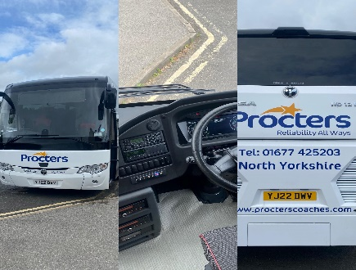
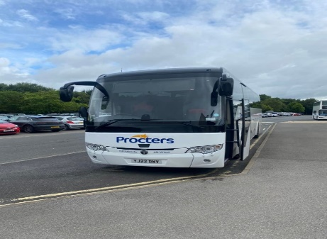

All drivers are issued with a company uniform to wear when driving.
Our operations and administration staff are excellent at what they do and if possible, will try and accommodate and schedule work accordingly when needed. They make sure that you have your regular rest days and stay compliant of the DVSA & VOSA regulations
We have an open book policy and any driver who needs to discuss any matters within the company our door is always open. We will listen to constructive criticism and if any good idea is valid, we will look to implement it in to practice.
We have our own training school and trainer who will deliver training to a high standard. All CPC is run in house and paid for by Procters Coaches including any training for keeping drivers up to date. We conduct driving assessments and this is a way to help to reduce accidents and upskill drivers when needed.
The company has been established over 30 years based in North Yorkshire and over the years grew and acquired several other coach companies, we own Compass Royston, Esk Valley, Fourway, Caledonian Travel, Dales & District, Solus Coaches, plus we are the TEMSA coach sales dealer for the UK.
We have our very own on-site mechanics and workshop, body panel and paint shop, a drive through coach wash to make life easier for each driver who work for us.
Thank you if you have any questions please don’t hesitate to ask.
01677 425203 or email training@procterscoaches.com
Name;
__________________________________________________
Telephone number;
__________________________________________________
Email;
__________________________________________________
Driving licence;
__________________________________________________
Town you live in;
__________________________________________________

